**Ideation Phase**

**Define the Problem Statements**

|  |  |
| --- | --- |
| Date | 08 May 2023 |
| Team ID | NM2023TMID14694 |
| Project Name | Advanced Breast Prediction with deep learning |
| Maximum Marks | 2 Marks |

**Customer Problem Statement Template:**

Create a problem statement to understand your customer's point of view. The Customer Problem Statement template helps you focus on what matters to create experiences people will love.

A well-articulated customer problem statement allows you and your team to find the ideal solution for the challenges your customers face. Throughout the process, you’ll also be able to empathize with your customers, which helps you better understand how they perceive your product or service.

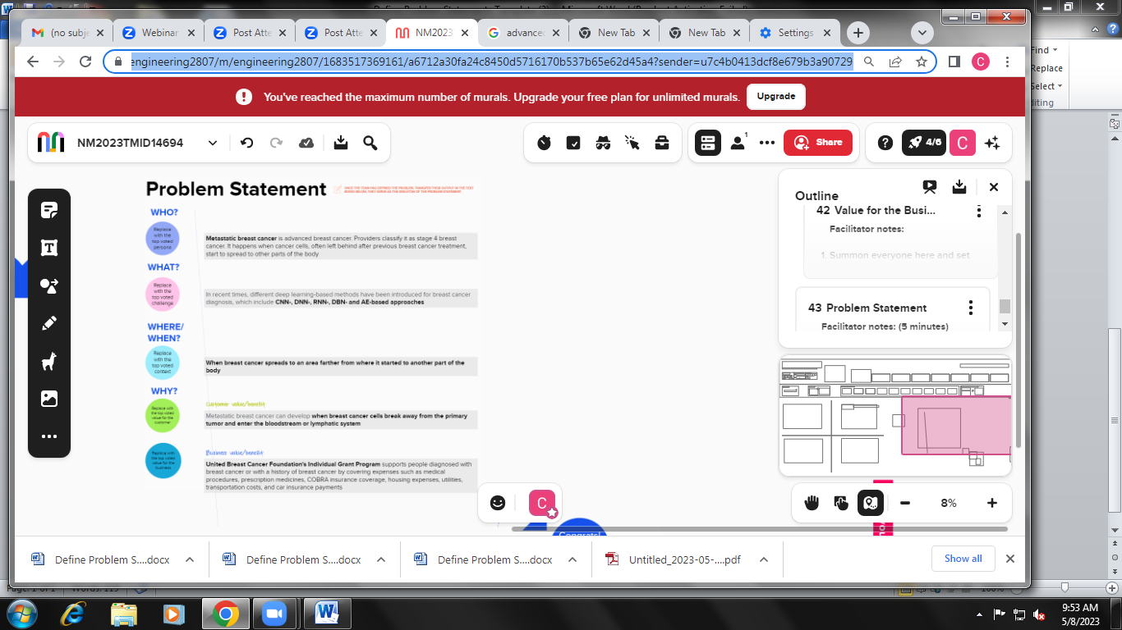

Reference: <https://app.mural.co/t/engineering2807/m/engineering2807/1683517369161/a6712a30fa24c8450d5716170b537b65e62d45a4?sender=u7c4b0>

**Example:**

|  |  |  |  |  |  |
| --- | --- | --- | --- | --- | --- |
| **Problem Statement (PS)** | **I am (Customer)** | **I’m trying to** | **But** | **Because** | **Which makes me feel** |
| PS-1 | I want a good software easy to use by people | I am trying to deduct the breast cancer | This cancer is body full affect | Metastatic breast cancer is advanced breast cancer. Providers classify it as stage 4 breast cancer | Bone pain or bone fractures due to tumor  Cells spearding to the bones or spinal cord |
| PS-2 | Easy to use by educated un educated people | Trying to gete knownladge about cancer | Spread from your breast to other parts of your body,  Most often to your bones,  lungs ,liver  ,or brain | It happens when cancer cells, often left behind after previous breast cancer treatment | Headaches or dizziness when cancer has spread to the brain |